

# Energy Monitoring Specification

# Services Monitoring

**Deliverables**

* Install and commission a full energy monitoring system to PLA specification
* Power monitor to be installed and configured as detailed in the installation guide
* The air flow meter should be set up to IFM and S&C recommendations(see set up guide)
* An analogue bus module must be provided to read the flow meter.

Set up guide currently refers to Interbus, Ethernet IP to be included at a later date.

Services to be monitored are:

* Electricity
* Water
* Compressed Air

The standard environmental screens will be configured to display these values on every line side CMU. Values to be displayed are as followed:

* Air flow rate
* Total air usage
* Air cost
* Total air cost
* Water flow rate
* Total water usage
* Water cost
* Total water cost
* L1,L2,L3 voltages
* L1,L2,L3 Current
* Total electricity usage
* Electricity cost
* Total electricity cost
* Tonnes of Co2 produced
* Total energy cost
* Power consumption

# These values are to be displayed using the CMU example displays shown in the master CMU application file.Concept

**Electricity Monitoring -** This is to be monitored using the Rockwell PM1000 EM3 Ethernet module. Any current transformers and other equipment required should be supplied by your selves. The circuit transformers will be fitted in the A1 panel and the three phases to the power monitor will be separately fused.

Once the power monitor has been installed and commissioned Rockwell are then required to perform an application buyoff to check the settings and verify the readings.

**Compressed Air Monitoring** - This is to be monitored using the IFM Efector 300 Metris device. Data from the device is to be logged into the PLC from the 4-20mA output via Ethernet IP and from there to the overview system (If installed).

The analogue signal will require scaling in the PLC to reflect the actual value in litres per minute, a scaling factor already exists in the PLC and works for most applications but if this does not work then the scaling should be tuned until correct.

**Cooling Water Monitoring** - This is to be monitored using the IFM SM7000 device. Connectivity and data logging as for Compressed Air, above

# Overview System

Overview system to be installed if requested on a specific project and should use the CIMPOS systems interface. If CIMPOS cannot be used then a server running Rockwell RSPower/RSView will be installed as the central data logger for all zones.

**Services Monitoring Concept**

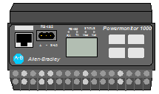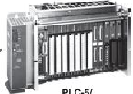

A2 Panel

A3 Panel

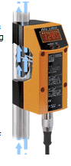

Ethernet

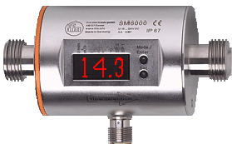

Compressed Air

Water

4-20mA

4-20mA

Field Bus

Controllogix

Rockwell PM1000

Flow Measuring

Overview system